University name: University of Wollongong (SCIT)
Module: CSIT128 Introduction to Web Technology
Assignment title: Assignment 1 (Group)

Group name:
Team members:

Wen Zihan
(UOW ID: 1487693 , Email : zw927@uowmail.edu.au )

Bryan Wong Zheng Ying
(UOW ID: 8376694 , Email : bzyw329@uowmail.edu.au )

Submission date: 21/04/2026

Table of Contents:
Part 1: Student Information Table ............. 3
Part 2: Hyperlinks and Images ................. 6
Part 3: Layout and Links ....................... 10
Part 4: HTML Form and JavaScript .............. 14

Part 1: Student Information Table

Screenshot of output

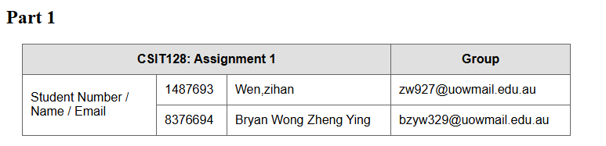
Code Snippet

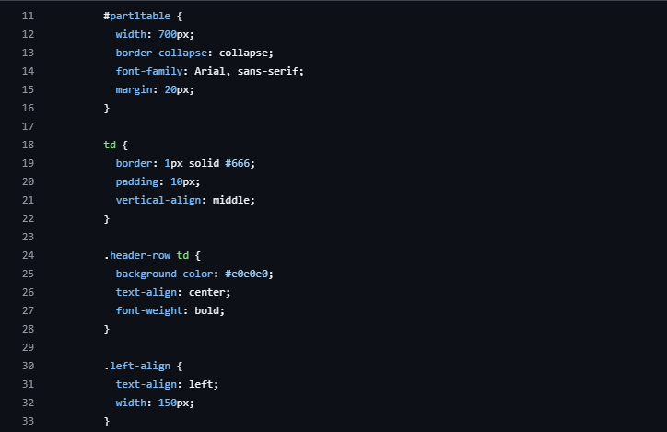
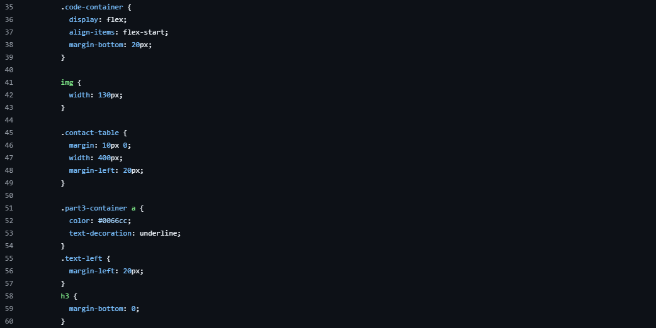
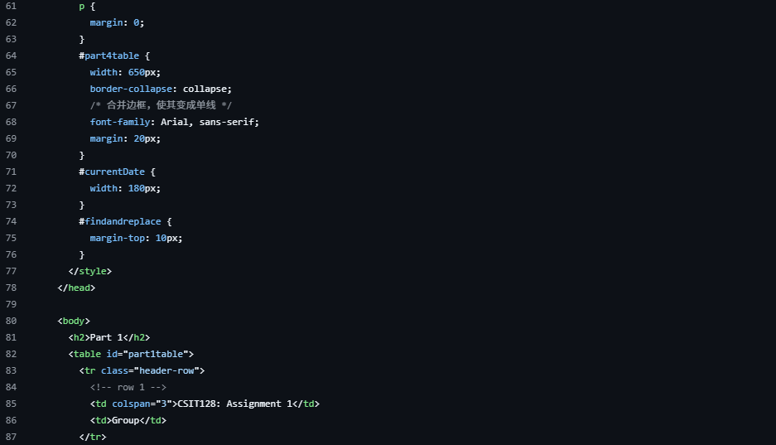
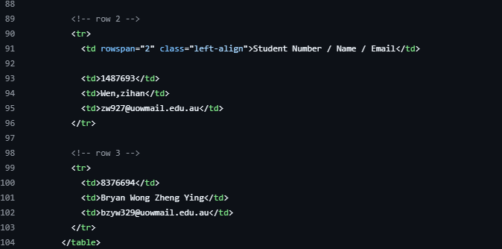

This code displays the group student’s information. It uses basic HTML structure and CSS styling for displaying the student’s information. The CSS styling defines the visual layout of the header. The HTML structure organizes the data using colspan to assign the columns and using rowspan to group the labels such as ‘Student Number/Name/Email’ along with the details.

Part 2: Hyperlinks and Images

Screenshot of output
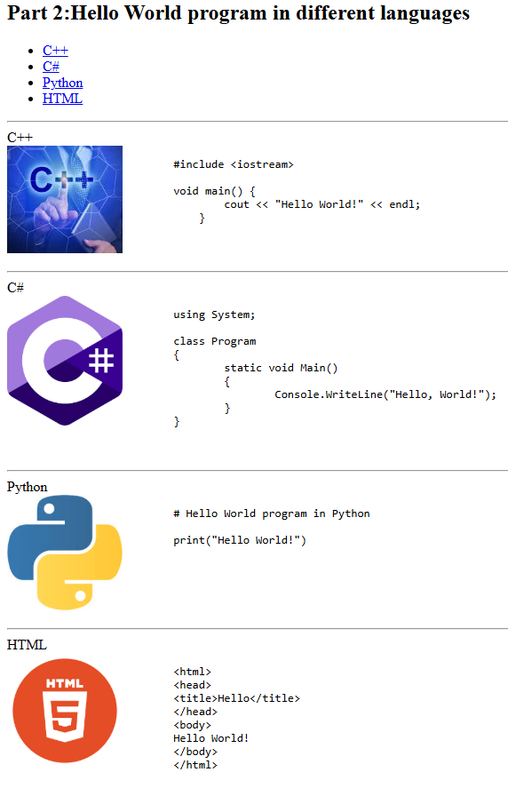

Code Snippet

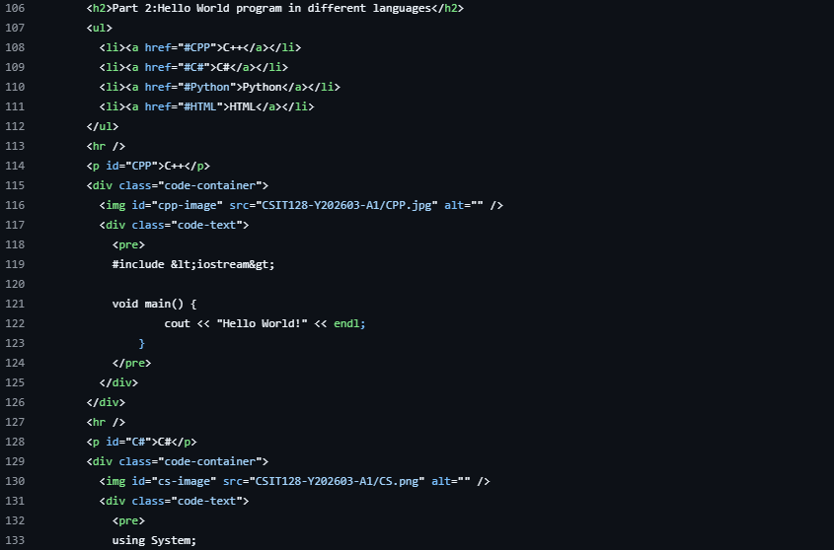
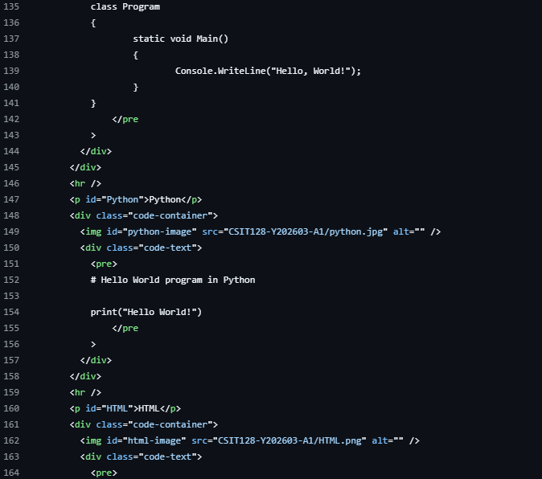
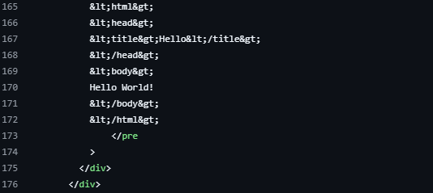

This part of the code creates a multi-language showcase of ‘Hello World’ by combining an internal navigation with a series of code blocks. It starts with an unordered list (<ul>) containing anchor links (<a>) which allows users to jump around specific sections such as (C++, C#, Python, or HTML) using id attributes. Each language is then paired with an image (<img>) with the source code wrapped in <pre> tags to preserve formatting and indentation. The code utilizes HTML entities (such as &lt; and &gt;). Visually, the sections are separated by horizontal rules (<hr />)

Part 3: Layouts and Links

Screenshot of output
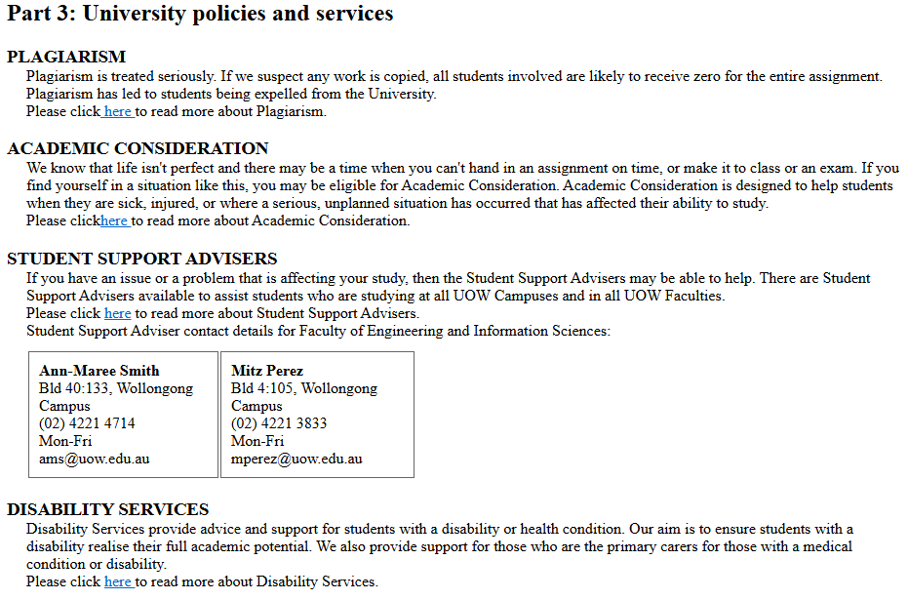

Code Snippet

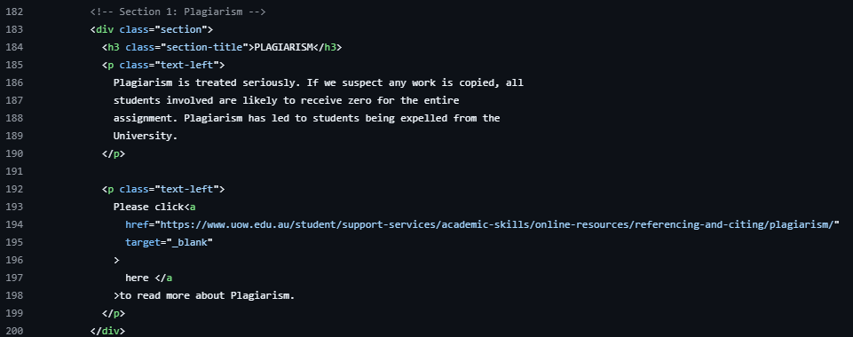
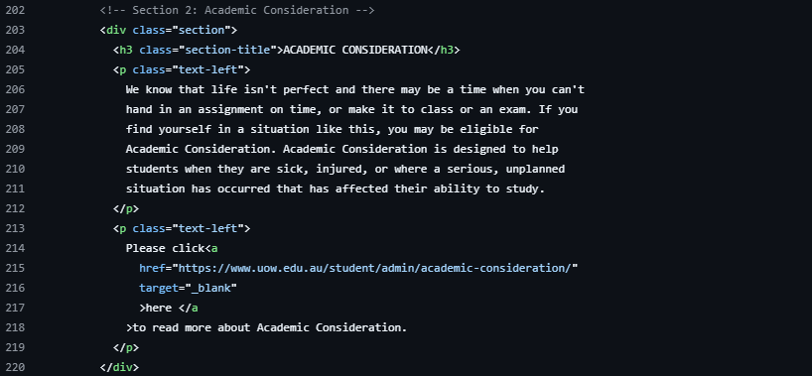
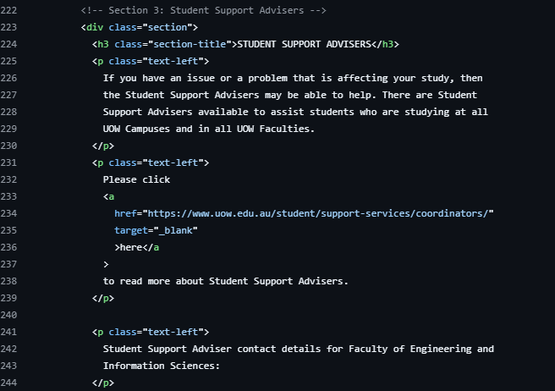
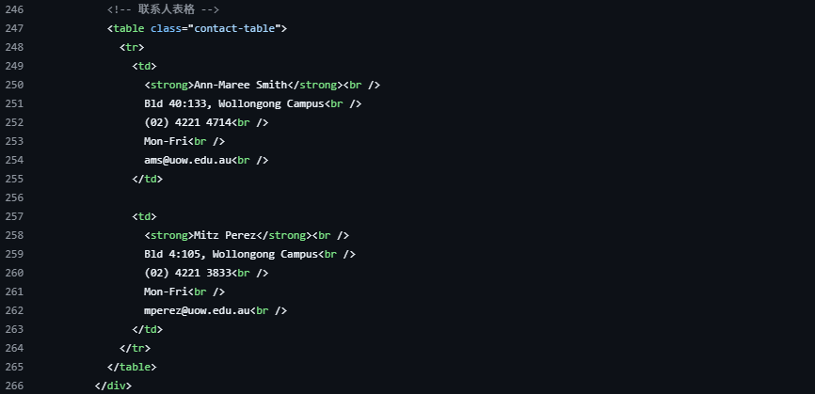
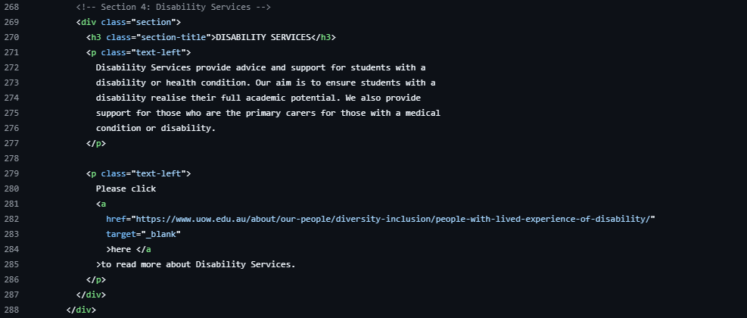

This part of the HTML code focuses on the University policies and support services. The code is divided into four sections ‘Plagiarism, Academic Consideration, Student support, Disability services). Each is wrapped in <div class="section">.

The informational content uses <h3> for the heading and <p> tags for the body text. The class text-left is used for alignment.

Each section has a call-to-action link (<a>) that opens in a new browser tab , directing students to official University of Wollongong (UOW) resources.

Under the ‘Student support advisers’ section, a <table> is used to neatly display contact information for faculty-specific advisers. Using <strong> for names and <br /> tags to create a compact, vertical list of contact details.

Part 4: HTML Form and JavaScript

Screenshot of output

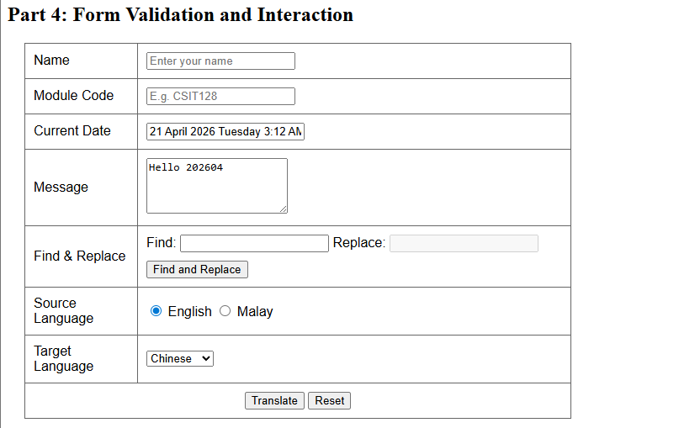

Code Snippet

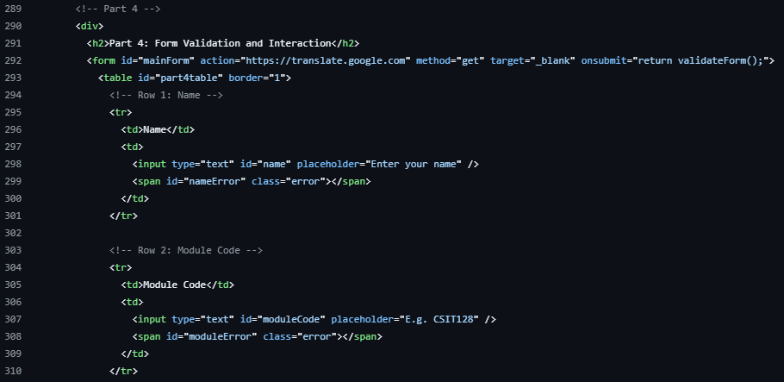
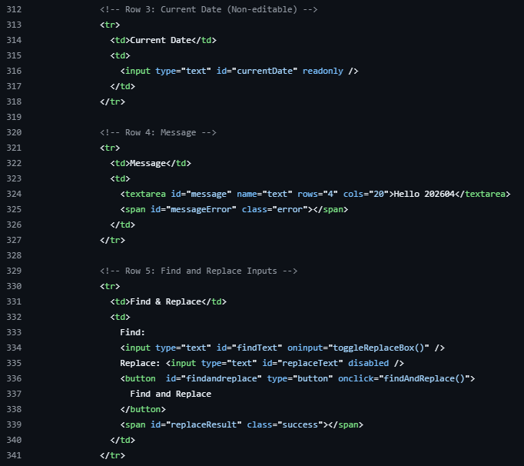
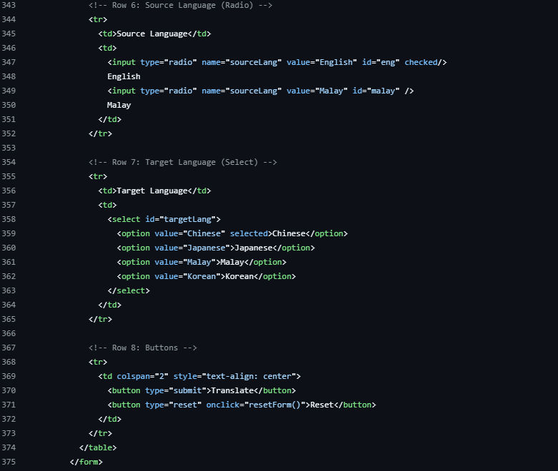

This code defines a functional user interface for a translation tool that is organized within a table. It uses a variety of input types such as standard text fields for user names and module codes, a read only field for date, text area for the message with the use of radio buttons and dropdown menus to select source and target languages. It incorporates JavaScript hooks like onsubmit="return validateForm();" for data verification, oninput to dynamically enable or disable the "Replace" field, and a "Find and Replace" button. The form then sends its data to Google translate.

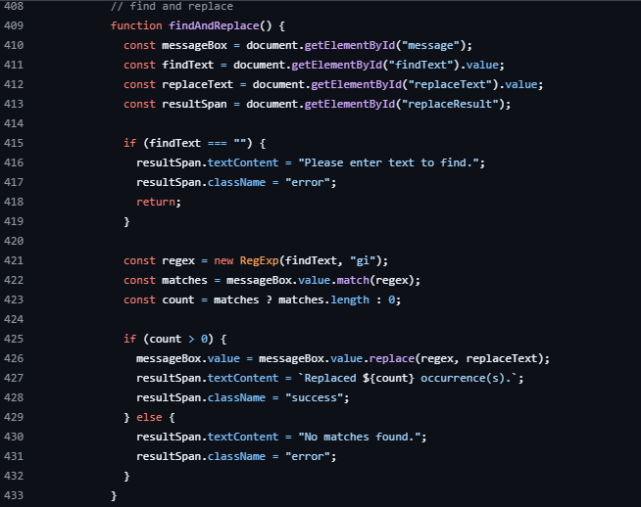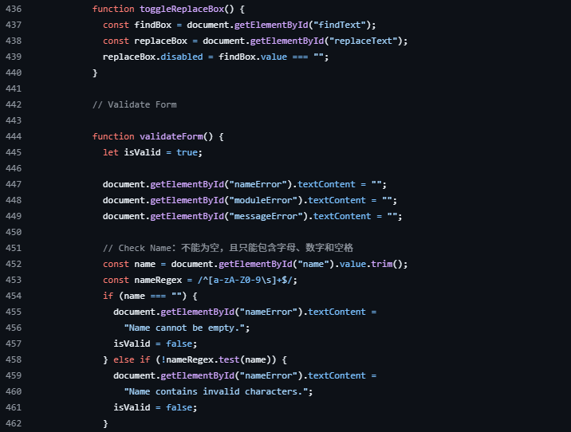
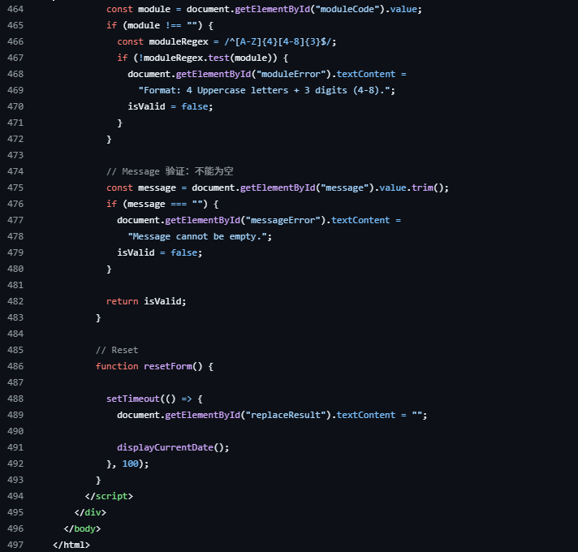

This is the Javascript code. The script is also equipped with find and replace functionality, which utilizes Regular Expressions (RegEx), and performs matching inside a message box while showing how many matches were made. Also, the script comes with a powerful validation mechanism, which guarantees the adherence to certain patterns, including making sure that the name is comprised of only alphanumeric symbols, that the message is not left blank, and that the module code fits a certain regex pattern, namely consists of four capital letters followed by three digits ranging from four to eight. Lastly, the script controls the state of input fields as well as the reset of the form.

